JAVA 3 Ativity 8 Task 3

30003389 – Kyer Potts

Table of Contents

Table of Contents i

Commenting code 1

Generating the JavaDoc 2

IDE Javadoc Generation 2

Command Line Javadoc Generation 3

Opening the Javadoc 6

# Commenting code

The Javadoc utility requires code to be commented in /** blocks, this enables it to separate publishable user comments into the javadocument html files

Javadoc also includes commenting tags to differentiate between differing items of code:

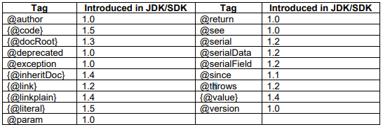

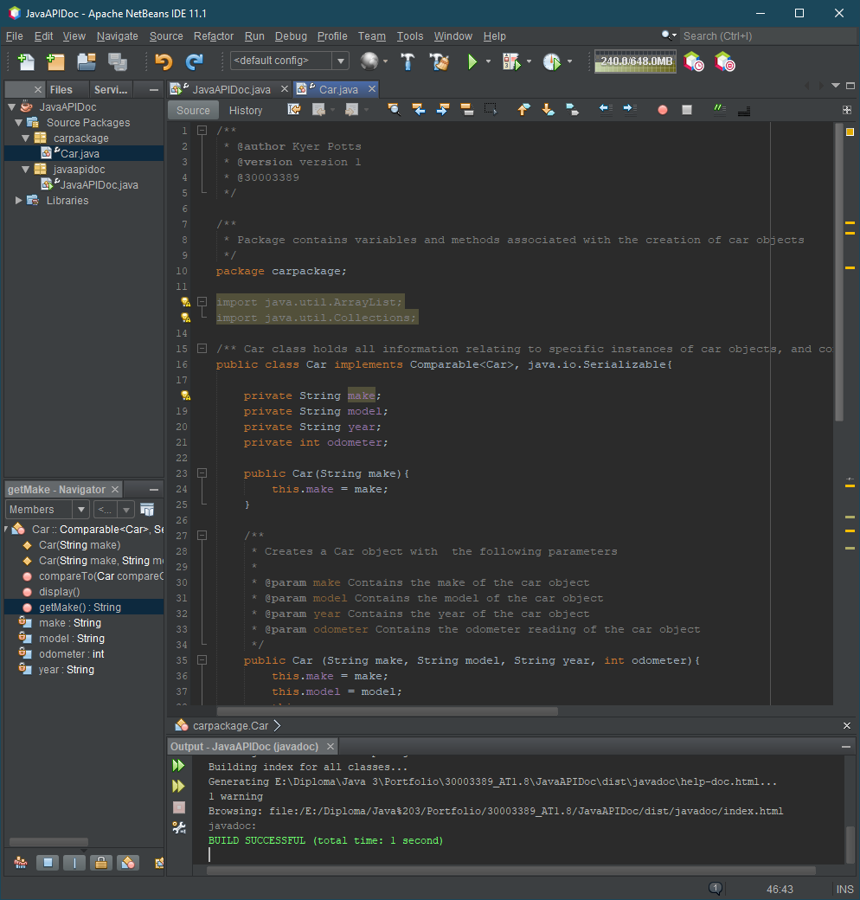

# Generating the JavaDoc

The JavaDoc can be created in 2 ways, via the Javadoc utility that can be called via the command line, and using an IDE utility that automatically generates the Javadoc. I’ll outline the steps for both below

## IDE Javadoc Generation

Once the comments have been added appropriately, the Javadoc can be created by clicking run, and selecting Generate Javadoc (JavaAPIDoc) option from the dropdown menu

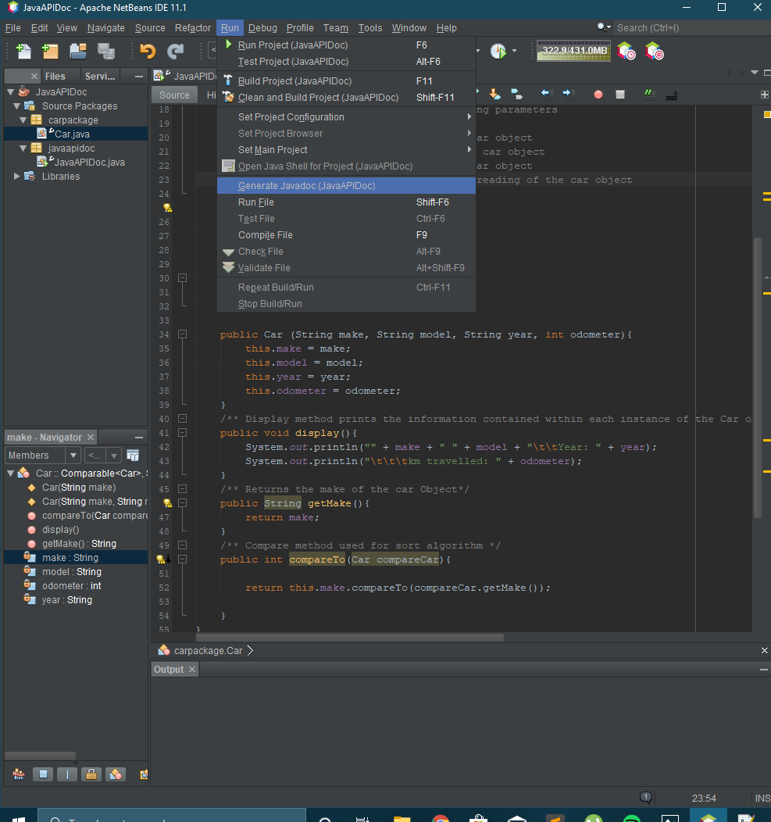

This will run the Javadoc utility and produce the Javadoc output in the “dist” folder of the project files

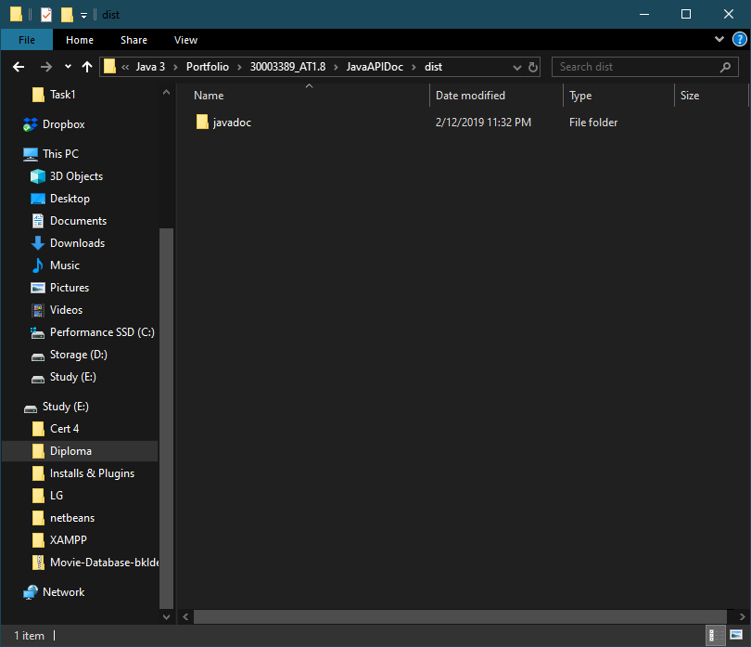

## Command Line Javadoc Generation

First, a java file containing the package information for the package must be placed within the package folder of the class that the Javadoc will be generating from.

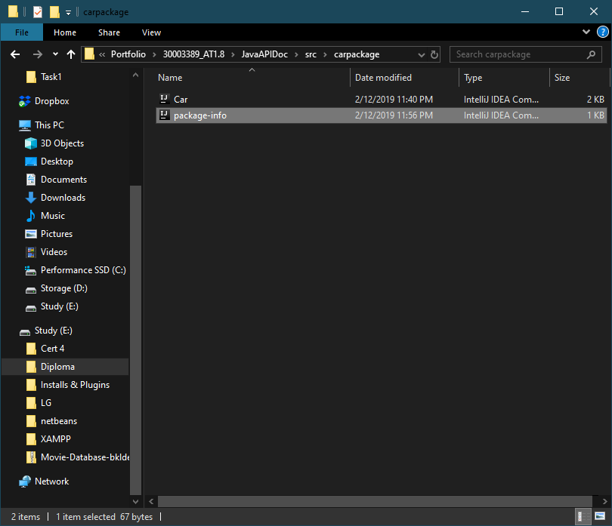

Ru the command line to fid the directory that the .java file is contained in

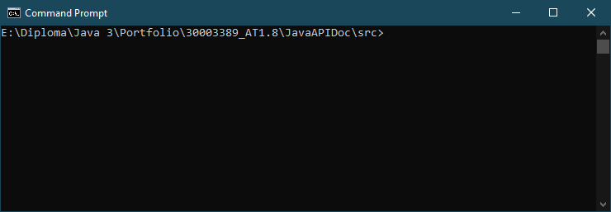

Then run the following command to generate the Javadoc

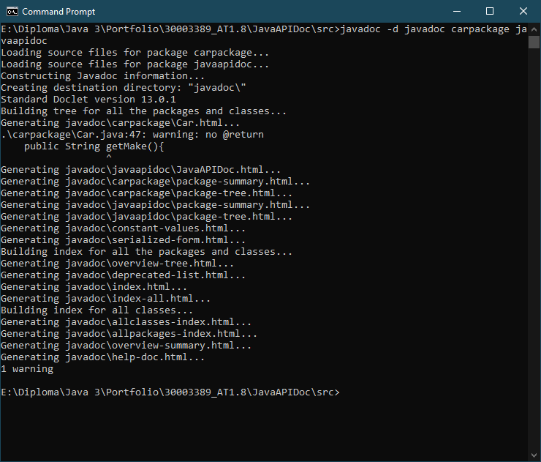

The Javadoc will then be generated within the file containing the package folders

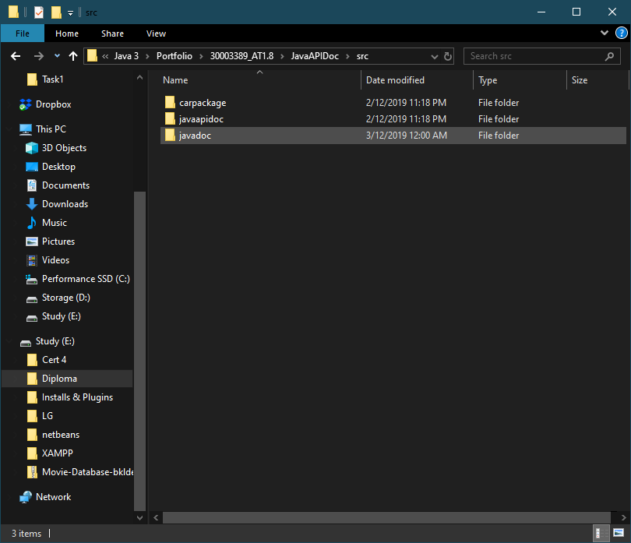

# Opening the Javadoc

To open the Javadoc, locate the folder containing all of the html files and select the index.html file to open it

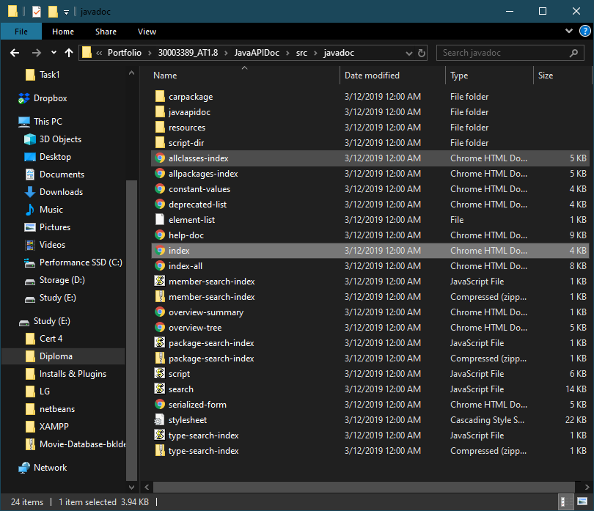

This will open the Javadoc containing all of the information within the comments made in the .java class files

